

Assessment Cover Page
Student Full Name
Erick Henrique da Silva
Student Number
2026297
Module Title
Statistical Techniques for Data Analysis
Assessment Title
CA1 – Statistical Techniques
Lecturer/Supervisor
Taufique Ahmed
Assessment Due Date
01/11/2026
Date of Submission
28/10/2026
Use of AI Tools

I acknowledge the use of ChatGPT, Grammarly and Claude for the purpose of improving my spelling and grammar, in addition to helping me better understand the assessment and organize ideas and statistical concepts that could or could not be applied in the assessment.
Declaration
By submitting this assessment, I confirm that I have read the CCT policy on academic misconduct and understand the implications of submitting work that is not my own or does not appropriately reference material taken from a third party or other source.
I declare it to be my own work and that all material from third parties has been appropriately referenced.
I further confirm that this work has not previously been submitted for assessment by myself or someone else in CCT College Dublin or any other higher education institution.

Contents
Introduction 1
Descriptive Statistics 1
Dataset Overview 1
Variables 1
Full-Time Result (FTR) 2
Full-Time Home Goals (FTHG) 3
Data Quality 4
Binomial and Poisson Distribution 4
Binomial Distribution: Home Win 4
Poisson Distribution: Home Goals 5
Large Samples 5
Normal Distribution 7
The importance of Distributions and the choice of variables 7
Conclusion 8
References 9
Appendix 9

Introduction
This report intends to analyse the Premier League match outcomes statistically, more precisely the last 10 years, between the seasons 2016-17 to 2025-26 using statistical techniques and statistical logic. For that was resort the dataset from DataHub, a reliable source of data that was read and combined to generate a single table in Python with all the matches from Premier League football Championship. The main goal is to describe the dataset through Normal, Binomial and Poisson Distribution to explain all the results obtained analysing the goals and shots from every match, after organized and critically analyse of this dataset, searching to understand and make the best use of it. The Analysis is accomplished using Jupyter Notebook with the help of Pandas, NumPy, Matplotlib and SciPy Libraries.

Descriptive Statistics

Dataset Overview
The Dataset generated by aggregating the last 10 seasons of Premier League match outcomes, being each season 380 rows, have in the total 3,800 rows, given that it row is a different match which were played for 2 different teams, and 22 columns with various variables, like the name of the team who is playing in house (HomeTeam), the another team who is playing away (AwayTeam), the date when the match was played (Date), the Full Time Home Goals (FTHG), the Full time Away Goals (FTAG), The Full Time Result (FTR), Referee, Shots, Fault, Yellow or Red cards, Corners. Following the instructions about the Dataset 6 columns are text and 16 columns are numeric variables, more than the requested, having not missing data or erroneous data, therefore the cleaning process was not necessary. The total number of teams is 34, and there are 50 different referees, in this way, the analysis is focused on the match outcome and numerical variables, because charts of 34 teams or 50 referees would be very difficult to read.

Variables
The table below shows the main results of the describe() for the numerical variables.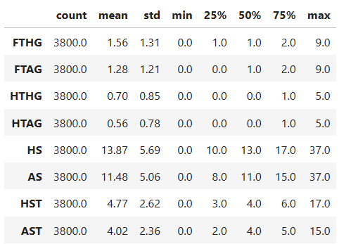
There are 3 results that draw attention. The first of all is the home team Advantage. For instance, they used to score more goals 1.56 x 1,28 for away teams, home team used to have more shots 13.87 x 11.48 and more shots in the target 4.77 x 4.02 and more corners also 5.66 x 4.69. The second important point to pay attention to is the shape, because for most variables the mean and median are very similar, but for goals, shots, and corners the mean is a bit bigger, so it means that probably the chart will have a tail on the right. And the third very important aspect is the type of data, because all the numerical variables are integers – discrete, therefore, it can probably work very well with Binomial and Poisson Distributions.

Full-Time Result (FTR)
The Home teams won 1.696 matches, Away teams won 1,221 and 883 was Draw matches. Being respectively H = 44.6%, A = 32.1% and D = 23.2%. Home teams used to win much more than Away teams – 12.5% more, and it confirms this advantage.
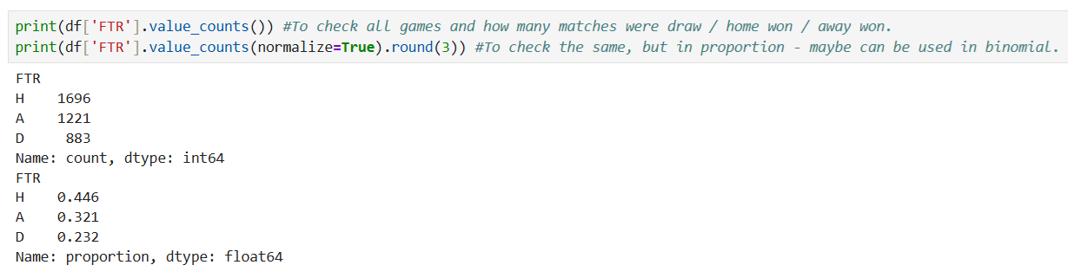
The easiest way to show this data is using a bar chart, because it is very understandable to compare categories.
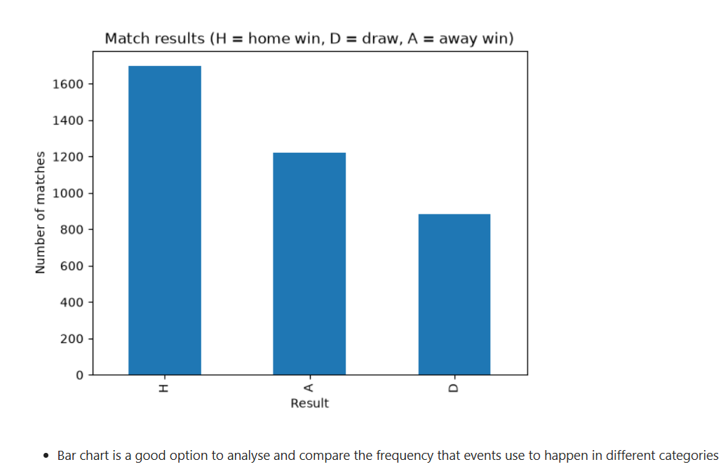

Full-Time Home Goals (FTHG)
Home goals are analysed in more detail because FTHG will be checked in the second part of this project. The number of goals per match ranges from 0 to 9, the mean is 1.56, the median and the mode are 1, the variance is 1.72, and the standard deviation is 1.31. In the graph below, which has to start from 0, the 0 and 2 bars are similar, and the biggest bar is at 1 goal, but there are some matches with many goals, which causes a tail to the right and makes the mean bigger than the median.
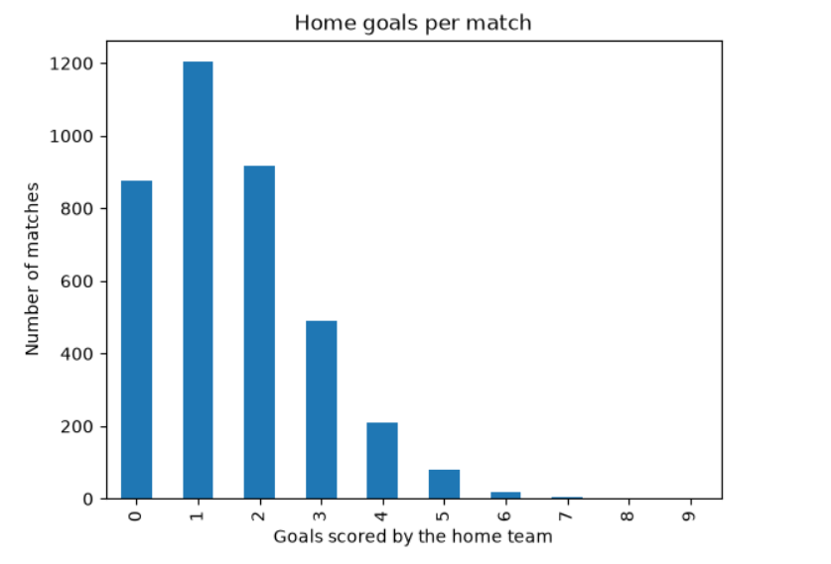
The next graph compares the Number of goals between Home teams and Away teams, and I used the boxplot model because it is a good option to visualize the outliers. The home team box goes from 1 to 2, while away team box goes from 0 to 2, what expose another advantage to play at home.
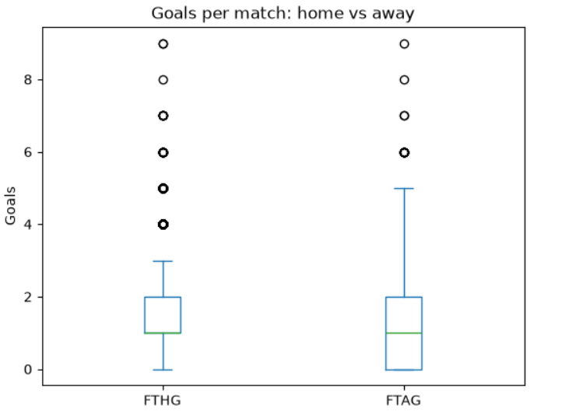

Data Quality
In 3,800 matches analysed, just 1 match had 0 Home shots, just 1 match had 0 Away shots, and only 2 matches had 0 Home Faults. It could be a mistake when it was registered or something very unusual happened, but it is a very small record to affect the data analysis. Therefore, this should not be a cause for concern.
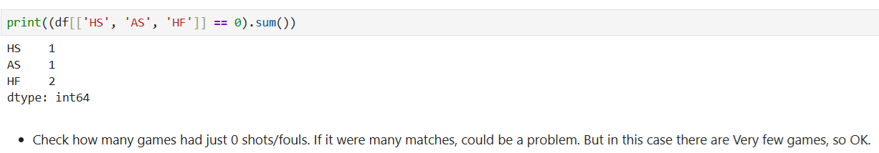

Binomial and Poisson Distribution

Binomial Distribution: Home Win
The Binomial Distribution counts the number of successes (k) in a fixed number of trials (n), when each trial has only 2 results with the same chances of success (p). In this case, one trial is one match, and one success is one Home Win, while Away and Draw are unified to be “Home Does Not Win”. For that was used p=0.446 (chances of home win), n=10 (number of matches). The most probable value is 4 Home Wins in 10 matches and after that 5 Home Wins, and the model predict than 0 or 10 Home Wins is very rare, the expected value is 4.46 Home Wins (10 x 0.446) and the Standard Deviation is 1.57.
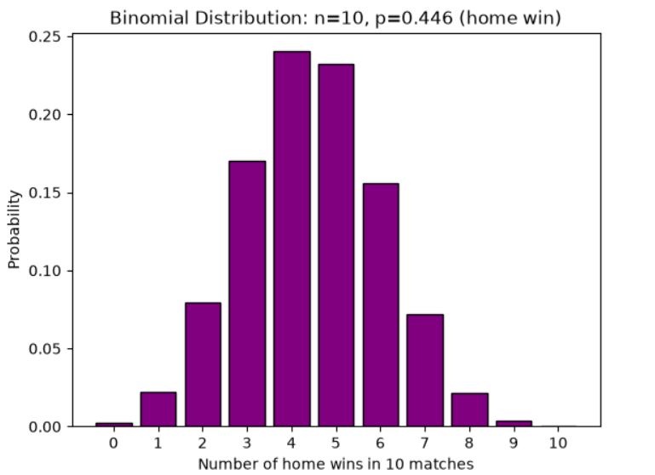

Poisson Distribution: Home Goals
The Poisson Distribution count how many times a event happens in a fixed interval, being this events independent and occurs in a constant average. Where the mean and the variance are the same and both equal lambda. In this case, the Home goals (the event) was analysed per match (fixed interval). The mean – 1.56 and the variance - 1.72 are close, which supports this choice. The most probable result is 1 Home goal, after 2 Home goals and after that 0 Home goals.
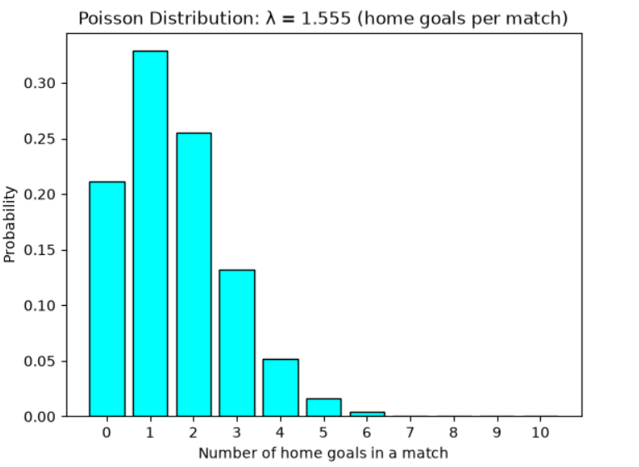

Large Samples
To work with Large Samples p was kept, and the number of events was increased for 5, 10, 30, and 100 matches. The centre of the graph moves to the right because the mean increases for 2, 4, 13 and 44, and it makes the shape become much more similar to a normal distribution.
In Poisson, the interval that was 1 increased to 10, and the mean that was 1.555 x 10 goes to 15.55, and the peak that was 1 goes to 15 goals, which makes the asymmetry almost disappear. Therefore, Large Samples in both cases cause the graphs to approximate a Normal shape.
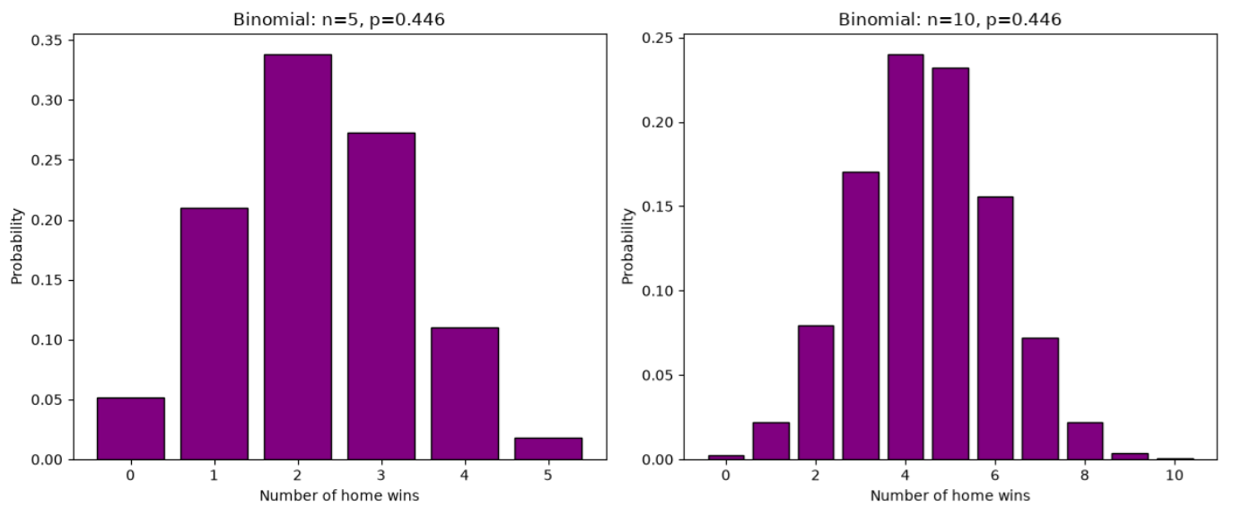
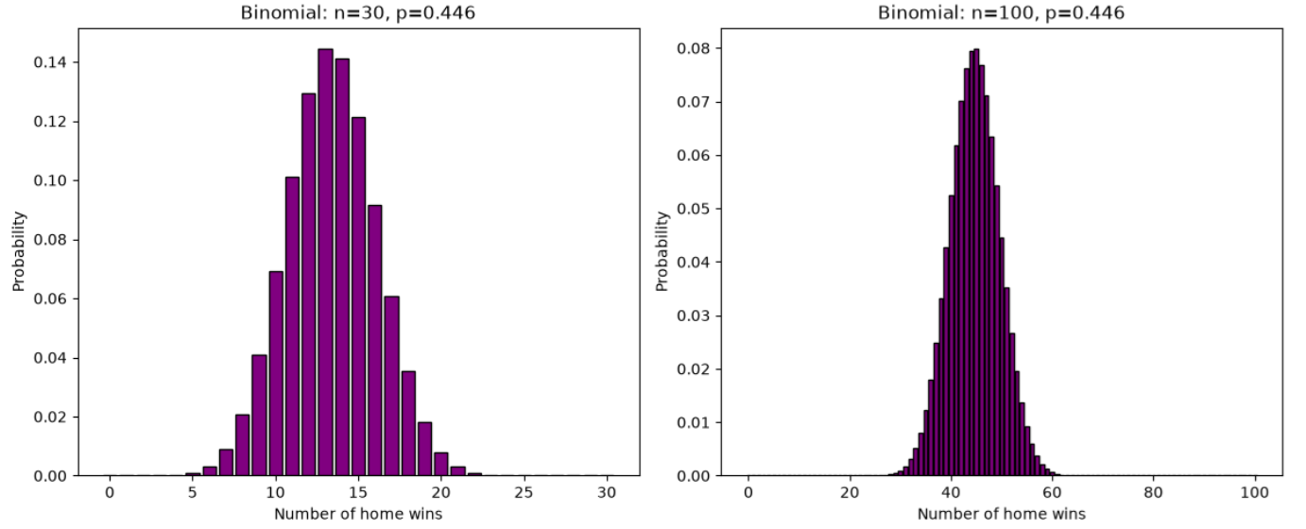
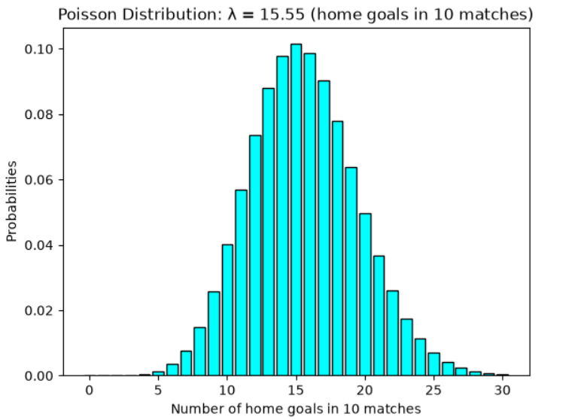

Normal Distribution
The normal distribution is symmetric, and it has a bell shape. The Home shots were chosen to be applied in this distribution because the goals don’t fit well (the majority of the matches are scored between 0 and 2 goals), while shots have a mean bigger and many different values are possible. And the mean is very close to the median, the standard deviation in the home shots is 5.69 and the skewness is 0.6. Therefore, there is a shape bell and the peak of shots is close 14, but there is a tail to the right yet, because some matches has many shots than the usual, so the home shots are approximately normal, however there is a moderate asymmetry to the right.
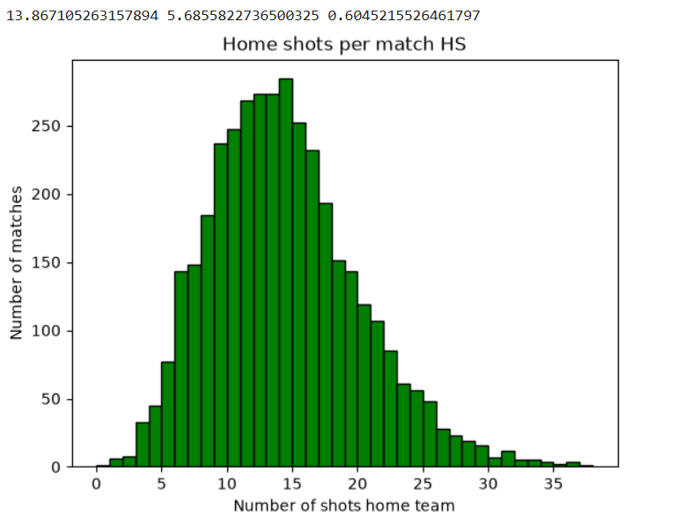

The importance of Distributions and the choice of variables
Each distribution plays a different role in this dynamic. Binomial was used to check yes or not outcomes in home win or home does not win in a number of matches, and Poisson is primarily used for home goals per match and the Normal describe the numerical variable of home shots with many values, that allow calculate probabilities with mean and standard deviation. The model analysed fits better with large samples because it approaches a normal distribution. To be analysed properly, each variable was chosen with the intention of being better established with each model.

Conclusion
This report showed that the teams playing at home are heavily favoured to win matches, score goals, and have more shots. The Home Wins can be used for a Binomial Distribution and the Home goals for Poisson distribution, with a small tail to the right, and the Home shots are Normal, with a small asymmetry to the right. Each distribution depends on the variable that will be analysed and large samples help Poisson and Binomial to approach to a Normal shape.

References
DATAHUB (n.d.) English Premier League (Football). Available at: https://datahub.io/football/english-premier-league (Accessed: 10 October 2026).

Appendix
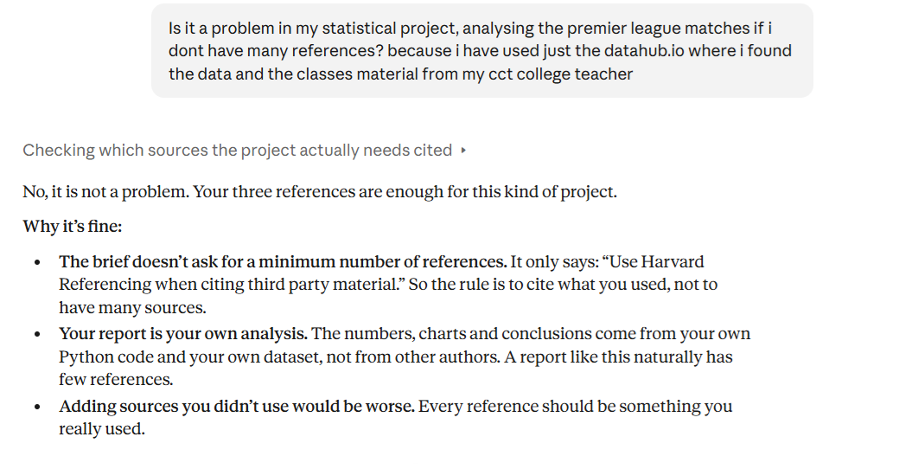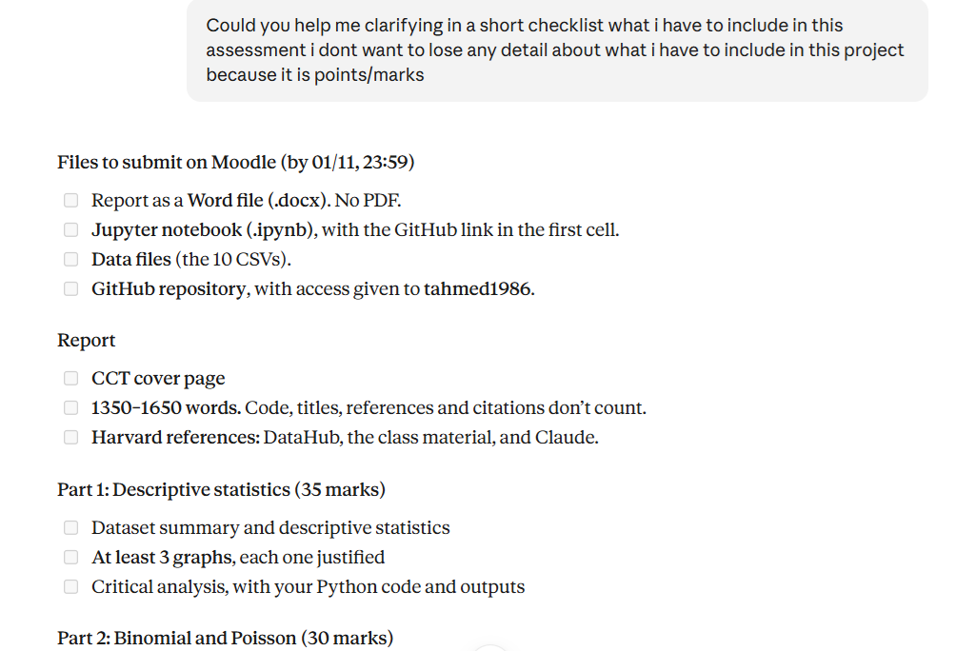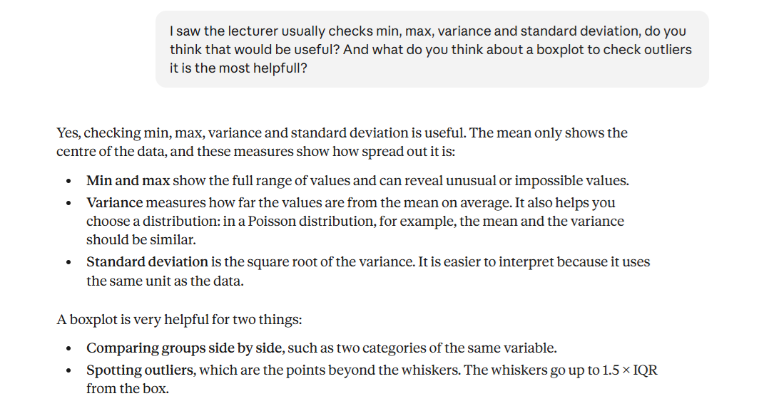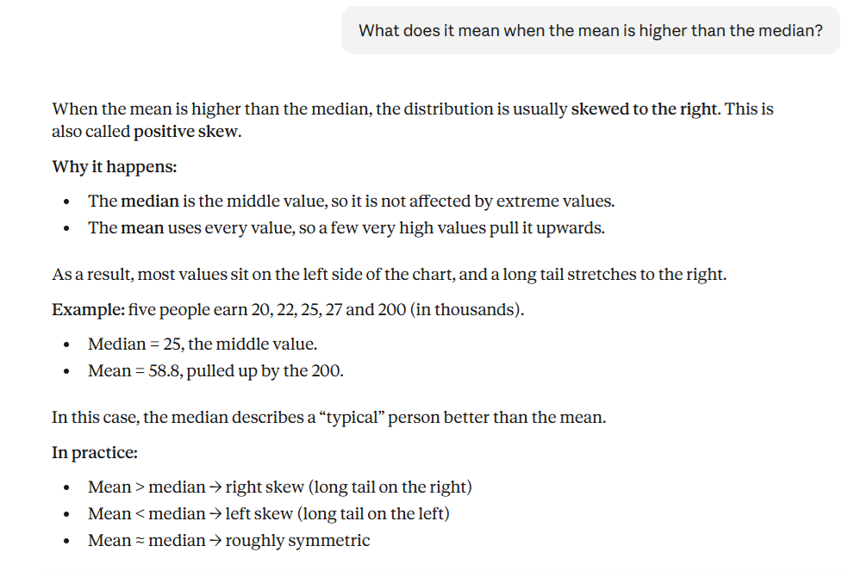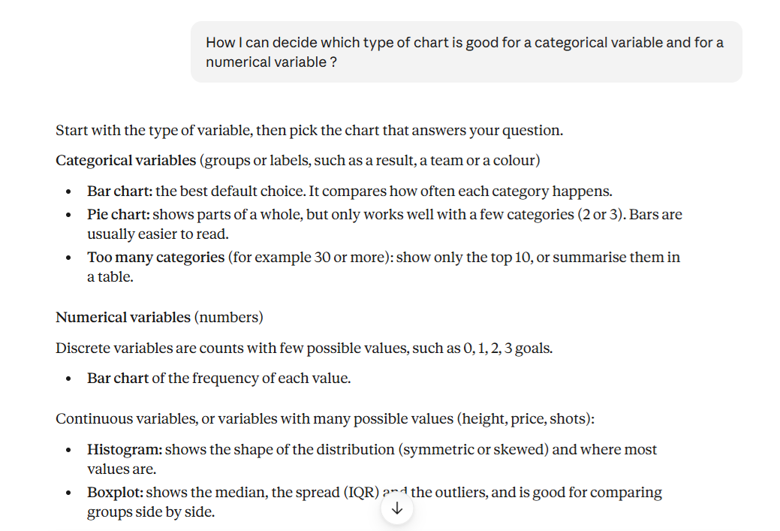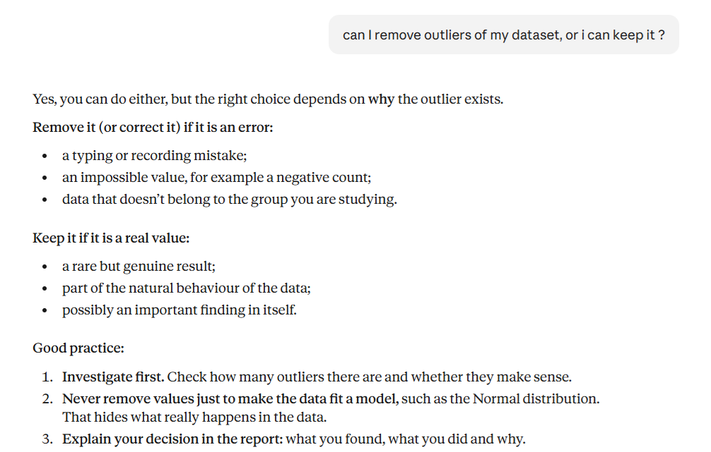
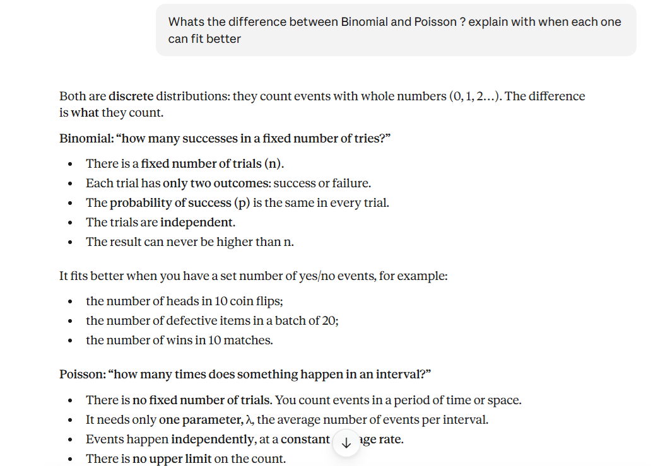

AI competence | Reflective prompts (to students) | Lecturer expectations | Student response
Delegation  Deciding whether & when to use AI | Identify the specific tasks in this assessment where you chose to use AI, and explain your reasoning. Where did AI add value? Where did you decide not to use it, and why? | You may use AI to support your learning and development of the application. Clearly identify where you used AI and where you completed the work independently. | I used it to explain to me the brief of this assessment, clarify statistical concepts and techniques, and check whether datasets and websites are reliable.
Description  How you prompted the AI | Include the exact prompts you used in your appendix (recorded on the AI Tools declaration). Reflect on how you communicated your goals to the AI — did you need to iterate or refine your prompts to get useful output? | You must provide the exact prompts and relevant AI outputs used during the development of your application. | Printed image on top.
Discernment  Evaluating what the AI produced | In your reflection, critically evaluate the AI output: what did you accept, modify, or reject — and why? Assess accuracy, relevance, and quality. You are responsible for verifying all AI-generated content before submitting. | You are responsible for checking, testing and understanding any AI-generated code or suggestions before using them in your work. | It was used just to confirm ideas previously known, and to clarify ideas but always following what I learnt in classes with teachers and in searching lesson content.
Diligence  Responsibility for your AI use | Declare all AI tools used and cite them here. Briefly outline how you considered data protection, copyright, and ethical responsibilities when choosing what to input into any AI system. Unauthorised use is subject to CCT disciplinary procedures. | Declare all AI tools used. Do not enter personal, confidential or sensitive information into AI tools. Any external sources used should be appropriately referenced. | I usually use ChatGPT and Grammarly and Claude, I open the result and resources to check exactly what I’m doing, like grammatical or mistakes.

